Sortieralgorythmen

# Struktogramm

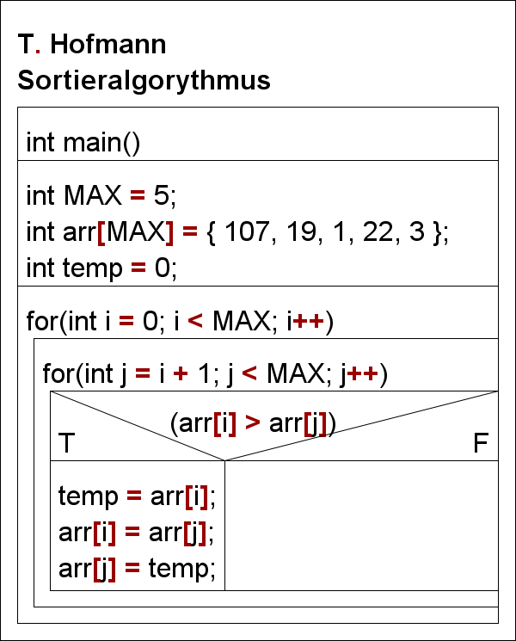

# Schreibtischtest

|  |  |  |  |  |  |  |
| --- | --- | --- | --- | --- | --- | --- |
| for | i | j | arr[i] | arr[j] | If(arr[i] > arr[j]) | temp |
| T | - | - | - | - | - | 0 |
|  | 0 | 1 | 107 | 19 | T | 107 |
|  | 0 | 2 | 19 | 1 | T | 19 |
|  | 0 | 3 | 1 | 22 | F |  |
|  | 0 | 4 | 1 | 3 | F |  |
|  | 1 | 2 | 107 | 19 | T | 107 |
|  | 1 | 3 | 19 | 22 | F |  |
|  | 1 | 4 | 19 | 3 | T | 19 |
|  | 2 | 3 | 107 | 22 | T | 107 |
|  | 2 | 4 | 22 | 19 | T | 22 |
|  | 3 | 4 | 107 | 22 | T | 107 |
|  | 4 | 5 | 107 | - |  |  |
| F | 5 | - | - | - | - | - |

Array: { 1, 3, 19, 22, 107 }